Facebook Ads For DFY Setup

Note: Copy this Ad details below and paste it on your ad setup page on Facebook; Headline, Body & Image

- Teeth Whitening:
a.BODY:Attention Ladies! Do you Have a Big Day Planned that you Want to look extra special for? Get This Amazing Teeth Whitening Device That Whitens your Teeth up to 10 shades!

This is Perfect for upcoming Wedding, Date or Meeting.
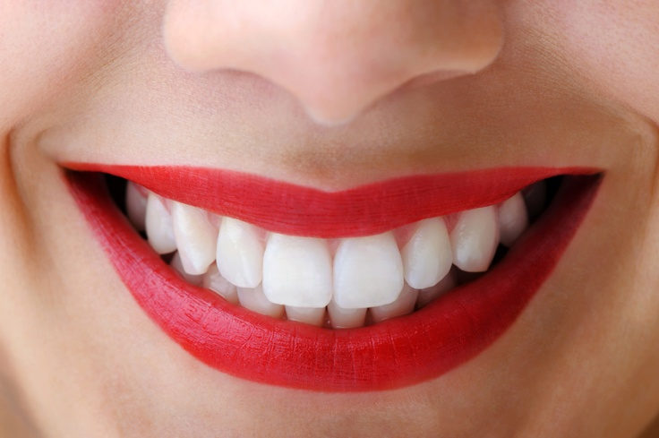
HEADLINE:Amazing Teeth Whitening Discovery
Click The Send Message Button To Place Order For Yours.

B.BODY: See How I Found A Simple Trick To Get White Teeth At
Home With Whitelight.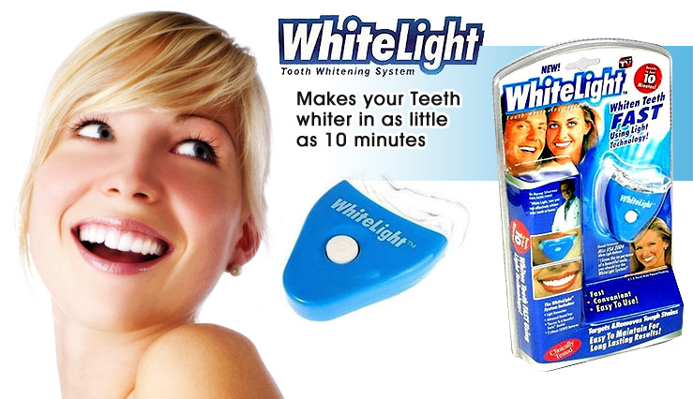
HEADLINE:Teeth Whitening Secret/Trick/Discovery
Click Here To Get Yours Now!

C. BODY:Whiten Teeths Instantly Up to 10 Shades, do it at home
under 10 minutes.
[VIDEO/IMAGE]
HEADLINE: WHITEN TEETHS UNDER 10 MINUTES!

- Facial Mask Peel
Body: See This Amazing Facial Peel-Off Cream that Get Rids of Darkspot, Pimples, Blackheads and Acne is 5 Minutes.
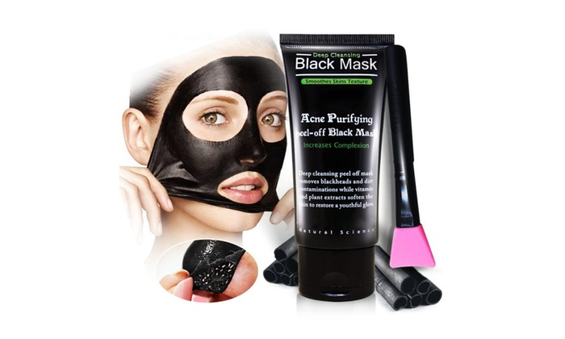
Or
HEADLINE: Get Rid of Acne,Pimple And Darkspot.
- Smart Tracker Device
Headline: Track Your Valuable Items With Smart Bluetooth Tracker
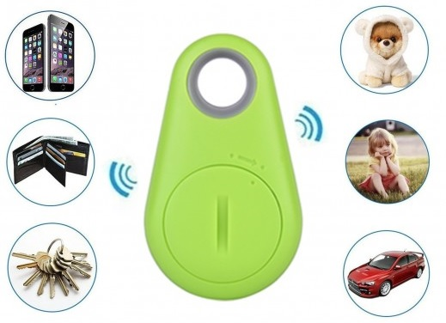
Body: Smart Bluetooth Anti-lost Tag Alarm Tracker Device For Monitoring Child & Old People,Phone,Pet, Bag, Wallet, Car and Key.

- Stretch Mark Cream
BODY: Bring Back Your Beautiful Skin WIth This Amazing Stretch Mark Removal Cream.
[IMAGE]
HEADLINE: GET RID OF STRETCH MARKS
Say Goodbye To Stretch Marks and Make Your Skin Glow WIth This
NEW Discovered Cream.
- Hair Growth Oil
BODY: Discover This Amazing Hair Growth Oil That Regrow Hair Without Any Expensive Surgery.
Headline:Amazing Oil Regrows Hair and Beards.

- Diabetes Patch
Headline: Reverse Diabetes 2 Without Pills
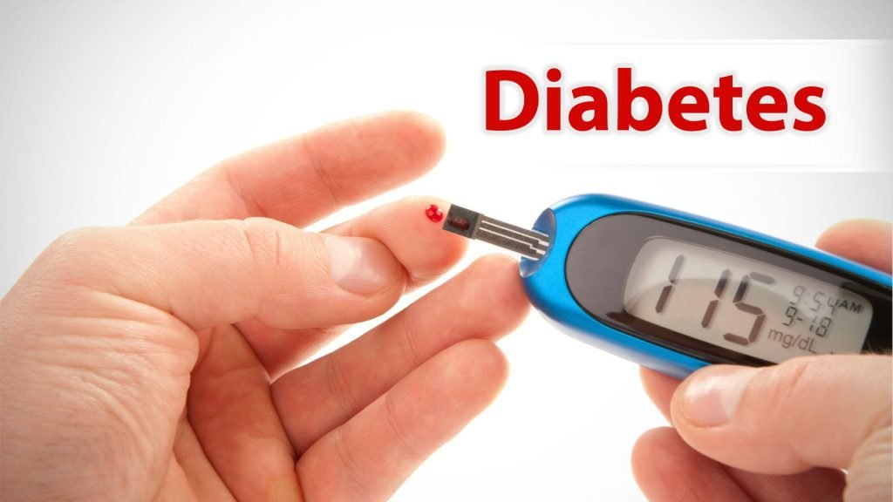
Body: Reverse My Type 2 Diabetes Without Taking Pills or Supplement Using This Amazing Diabetes Patch!

- Hypertension Patch
Headline: Lower Blood Pressure Without Pills
Body:The Exact Solution I Used To Lower My Blood Pressure Without Taking Pills or Painful Injections
BODY2: Miracle Patch That Completely Reverse Hypertension (High Blood Pressure) In Just 3Weeks Without Taking A Single Pill & Without Negative Side Effects Irrespective of Age.

- Car Fuel Saver
Headline: Save Car Fuel Up to 30%
Body: Miracle Device Save Your Car Fuel by 30%. Just Plug and Start saving Fuel Instantly.

